DBMS RECORD OUTPUT

1. Find the salary of all clerks and managers?

**CREATE**

create table Employee(Emp_id int Primary key,Empfname varchar(20),Emplname varchar(20),Dept varchar(20),Pjt varchar(20),Address varchar(50),DOB DATE,Gender varchar(20));

create table Empdesig(Emp_id int Primary key,Emp_position varchar(20),DateOfJoin DATE,Salary int,Foreign Key(Emp_id) REFERENCES Employee(Emp_id));

**INSERT**

**To find the salary of all clerks and managers?**

Select SUM(Salary) From Empdesig WHERE Emp_position IN ("Clerk","Manager");

**OUTPUT**

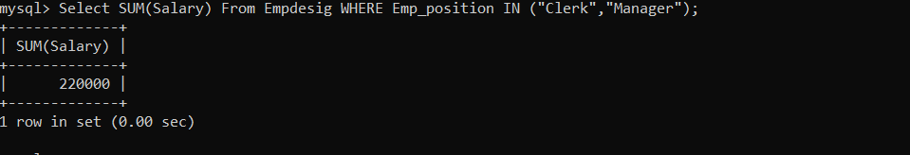

1. Fetch the no of employees working in the “HR” department?

Select COUNT(DEPT) FROM Employee WHERE Dept="HR";

**OUTPUT**

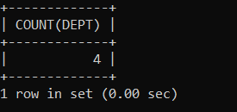

1. Fetch the first four characters of emplname from the employee table?

Select SUBSTRING(Empfname,1,4)FROM Employee;

**OUTPUT**

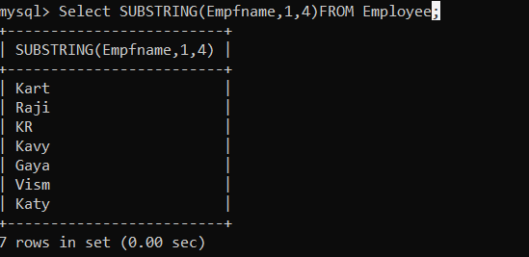

1. Find all employee details whose salary is between 10000 and 40000?

SELECT * FROM Empdesig WHERE Salary BETWEEN 10000 AND 40000;

**OUTPUT**

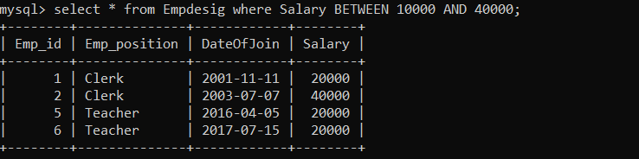

1. Create a new table which consists of data and structure copied from employee table?

create table NewEmployee AS(SELECT * FROM Employee);

**OUTPUT**

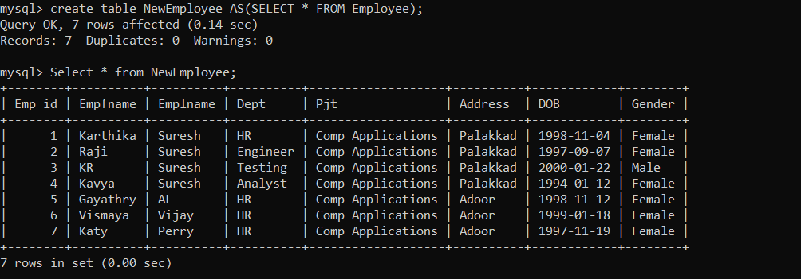

1. To find details of employees whose emplname ends with ‘ A’ and contains five alphabets?

SELECT * FROM Employee WHERE Emplname LIKE "%____a";

**OUTPUT**

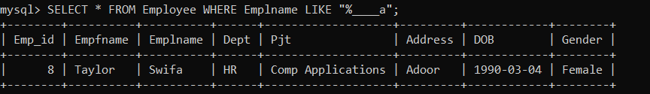

1. To add email validation to your database?

Alter TABLE Employee ADD Email varchar(200);

UPDATE Employee SET Email="taylorswifa@gmail.com" WHERE Emp_id=8;

UPDATE Employee SET Email="katyperry67@gmail.com" WHERE Emp_id=7;

select * from Employee where Email LIKE "%gmail.com";

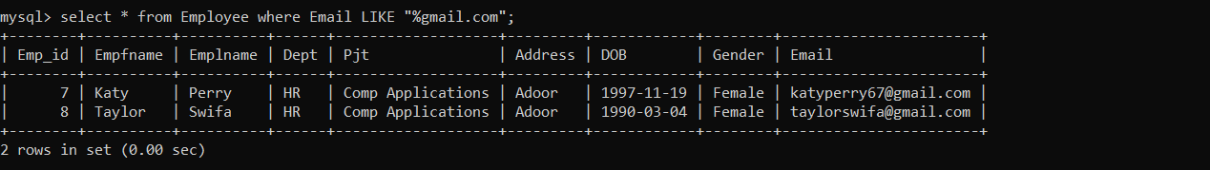**OUTPUT**

1. To find the second highest salary ?

SELECT Max(Salary) as SALARY FROM Empdesig WHERE Salary <(SELECT MAX(Salary) FROM Empdesig);

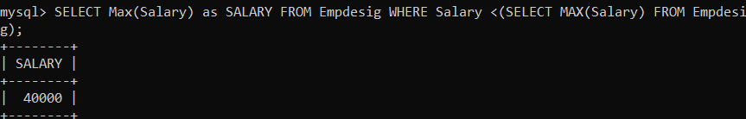

1. Write a plsql program

a. to display the message ” welcome to plsql”.

b.to check whether a given character is a letter or a digit.

begin

dbms_output.put_line('WELCOME TO PL/SQL');

end;

/

**OUTPUT**

WELCOME TO PL/SQL

b) to check whether a given character is a letter or a digit.

DECLARE

get_ctr varchar2(20) := '&input_a_character';

BEGIN

get_ctr:=:get_ctr;

IF ( get_ctr >= 'A' AND get_ctr <= 'Z' ) OR ( get_ctr >= 'a' AND get_ctr <= 'z' )

THEN

dbms_output.Put_line ('The given character is a letter');

ELSE

dbms_output.Put_line ('The given character is not a letter');

IF get_ctr BETWEEN '0' AND '9' THEN

dbms_output.Put_line ('The given character is a number');

ELSE

dbms_output.Put_line ('The given character is not a number');

END IF;

END IF;

END;

/